Computer Language Coding Concepts

Parameters in a Command Definition in a Diagram
This article demonstrates a situation of command objects.

This article illustrates how parameters in a command definition look in a diagram. The diagram below displays an inactive command definition with parameters:

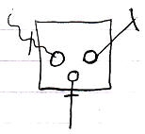

The square is a command definition. The circles inside of it are the parameters. The rest of what’s visible in the diagram are the parameter passings. Parameter passings are explained in the parameter articles. The parameter passings are the lines connected to the circles, that are marked with an access mark.

See also: Commands

Author & Copyright: Jan-Joost van Zon Date: August 9, 2008 – August 23, 2008 Location: Oosterhout, The Netherlands Status: Finished

